**Project Overview: DebateVerse**

**Introduction**: DebateVerse is a web application designed to foster thoughtful discussions and promote diverse perspectives. Users can post debate topics with multiple viewpoints, engage in meaningful discussions, and express their opinions through likes or dislikes. The platform also includes search functionality to explore debates.

**Key Features**:

1. **Topic Creation**:
   * Users can create debate topics with 2 to 7 viewpoints.
2. **User Interaction**:
   * Like or dislike debate topics to express opinions.
3. **Search Functionality**:
   * Explore debates based on keywords.
4. **User Authentication**:
   * Secure login and registration system.
5. **Role-based Access**:
   * Admin and user dashboards with specific functionalities.

**Tech Stack**:

* **Frontend**:
  + **React.js**: For building dynamic user interfaces.
  + **Tailwind CSS**: For efficient and responsive styling.
* **Backend**:
  + **Node.js**: For server-side logic and handling requests.
  + **Express.js**: To streamline API development.
* **Database**:
  + **MongoDB**: To store user data and debate topics securely.

**Libraries Used**:

1. **Frontend Libraries**:
   * axios: For making API requests.
   * react-icons: For adding icons to the user interface.
   * react-toastify: For displaying notifications.
2. **Backend Libraries**:
   * jsonwebtoken: For secure user authentication.
   * bcrypt: For hashing user passwords.
   * mongoose: For MongoDB object modeling.
   * nodemailer: For sending email notifications (e.g., account activation).

**Screenshots**:

* Home Page



* About Page

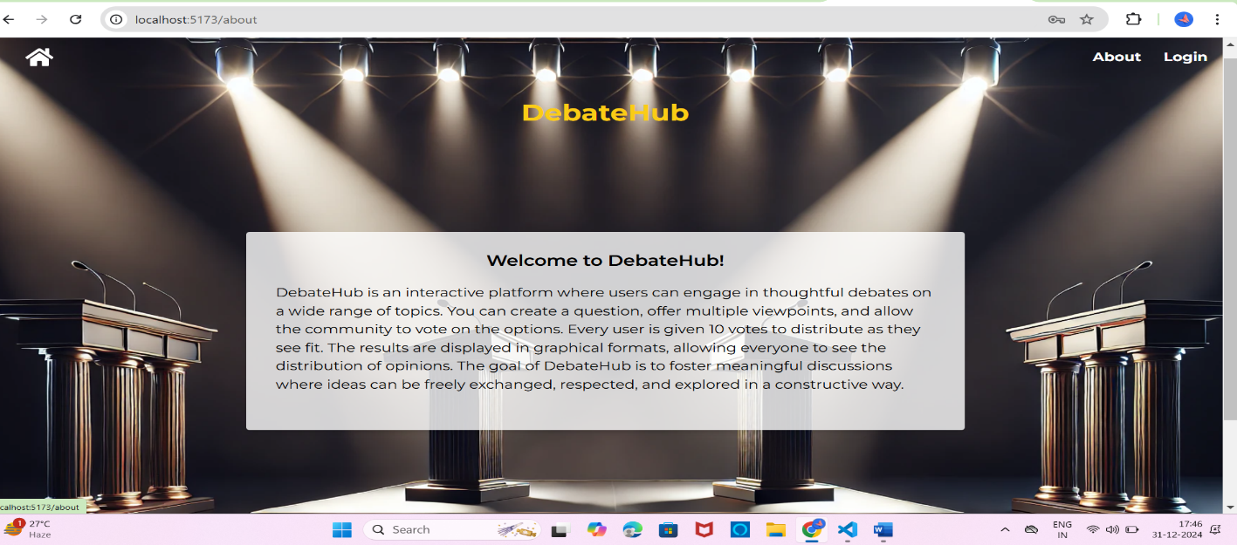

* Login Page



* Register Page

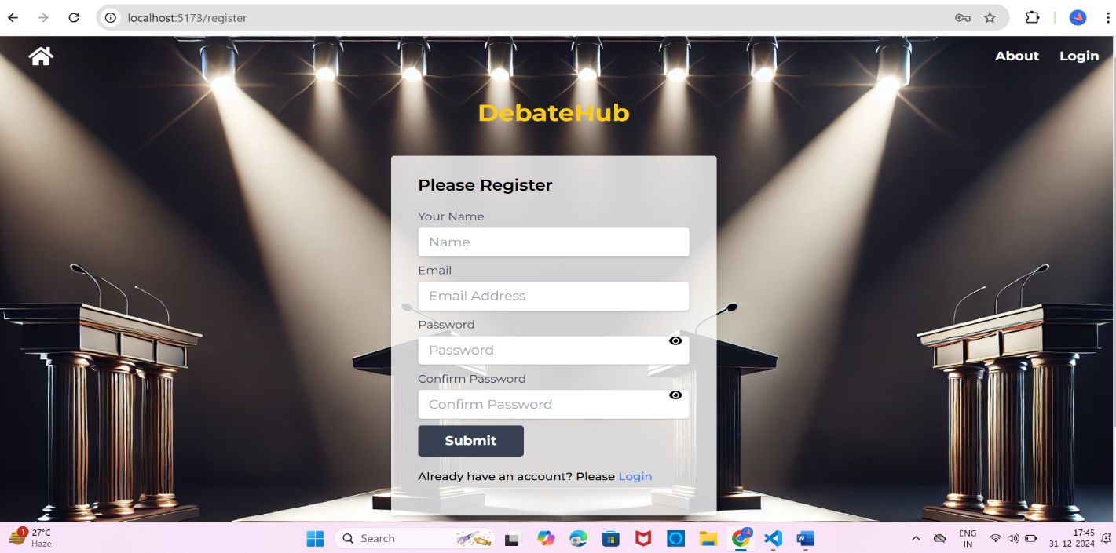

* User Flow
* Userdashboard

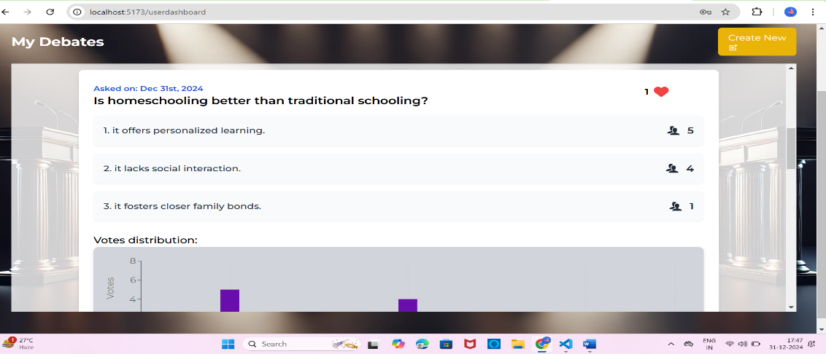

* NewDebate

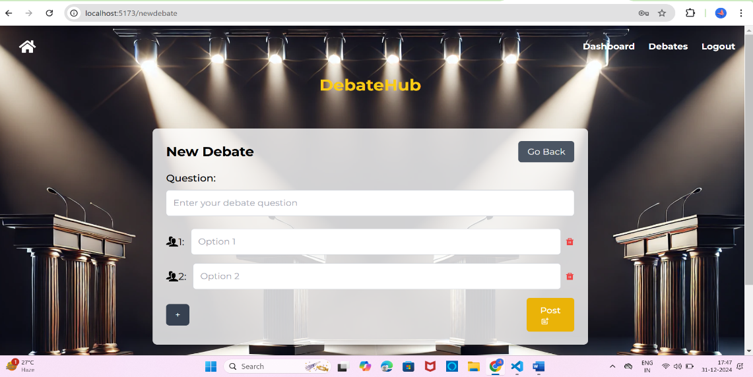

* All Debates

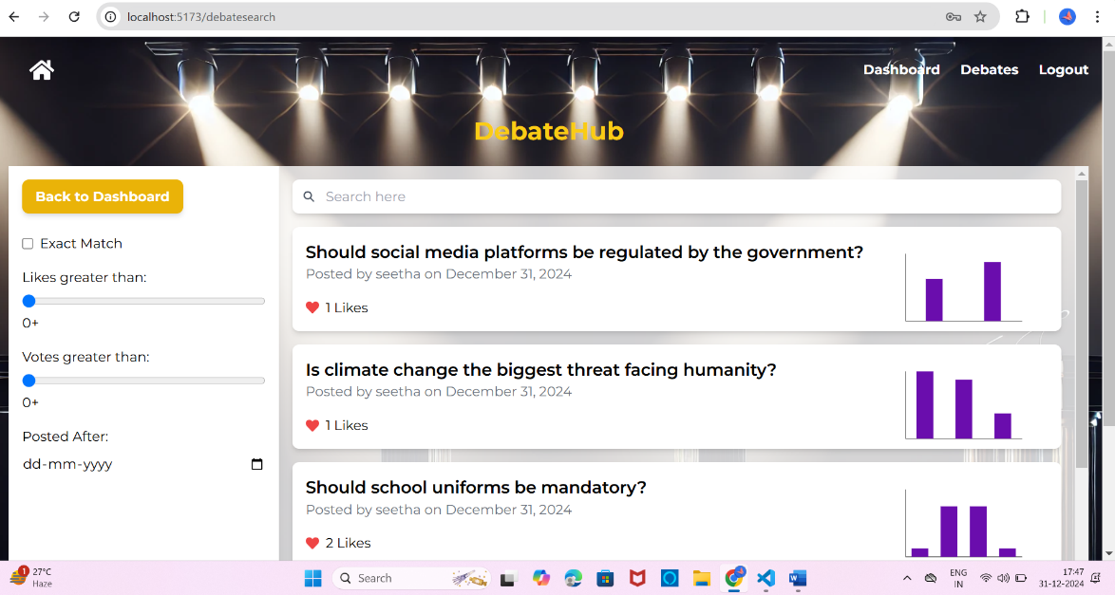

* Moderate Debate

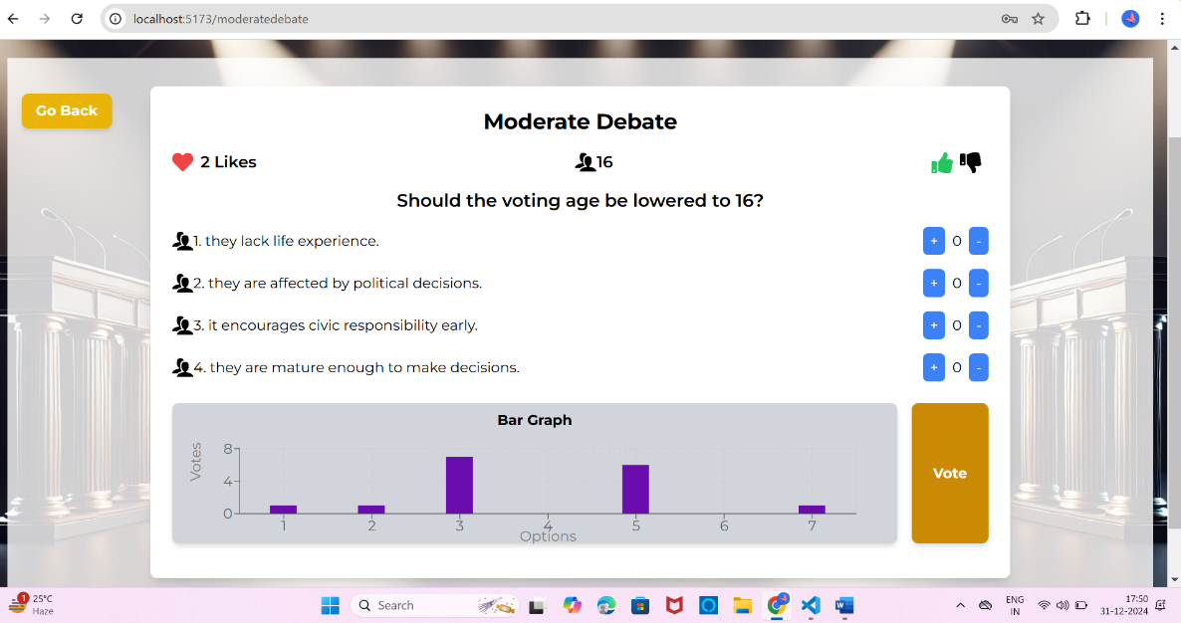

* Admin Flow
* AdminDashboard/Users

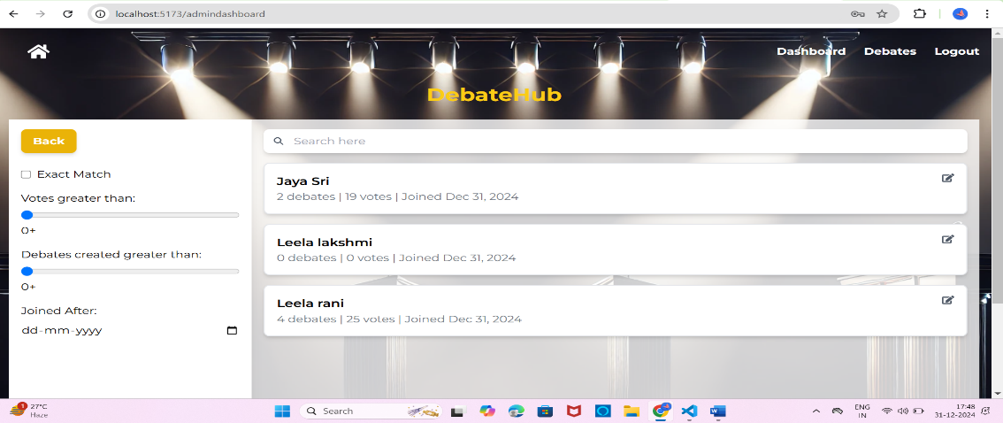

* User Block

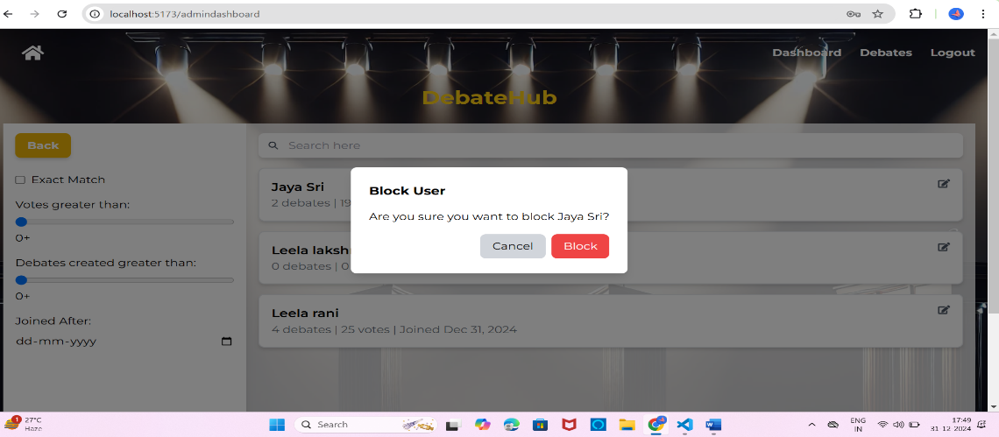

* Moderate Debate

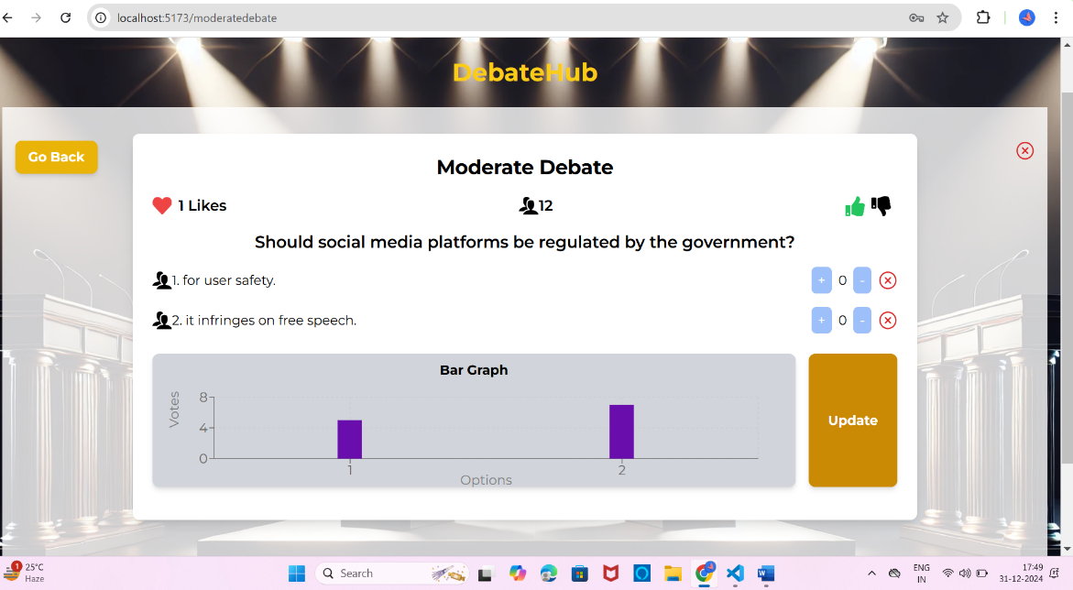

**Future Enhancements**:

1. Add a real-time commenting feature for debates.
2. Implement AI-powered sentiment analysis for user opinions.
3. Introduce gamification elements, such as badges for active participants.

**Conclusion**: DebateVerse aims to provide a platform where users can exchange ideas, learn from diverse viewpoints, and engage in productive discussions. With a robust tech stack and user-centric features, DebateVerse is a valuable tool for fostering healthy debate and understanding in a digital era.